AI Solution Factory — How It Works
Nov 2, 2026 · @tuncer

What it is
The AI Solution Factory turns a department's AI idea into a reviewed, developer-ready design package in six gated steps. It does not build the AI solution itself; the development team builds from the package it hands over.
It runs on Claude Code, Anthropic's AI assistant for working with files and tools. The factory gives Claude a fixed playbook: which questions to ask, which standard documents to fill, which specialist reviews to run, and which checks must pass before moving on. People make every decision that matters.
What you get at the end
- Clear requirements: what the solution must do, for whom, and how success is measured
- A design: the approach, the components and technology to use, where people approve AI work, and the security risks with their controls
- A backlog of user stories and a set of test examples with the correct answers
- A test plan and a rollout plan
- A full record of every decision, review and approval
What it does not do
- Write the production code
- Buy or select external products; it chooses only from the organization's approved internal technology
- Approve anything on its own; every gate needs a named person

Required information to start
A request can start once the five items marked Required are available; Claude can work from notes, emails, documents or spreadsheet exports, and asks about anything missing. The recommended items are needed later for design and testing, so providing them early saves question rounds.
Information | Required? | Why it is needed | Example
Request and sponsor: who is asking, what they want, why now | Required | Defines the problem; the sponsor signs off requirements | "AP wants AI to triage supplier invoices; sponsor Dana Lee, Director AP"
Current pain in numbers | Required | Sets the value score and the baseline for success measures | 6 minutes per invoice, 8% misrouted, one week behind at month end
Volume | Required | Sizes the value, performance needs and cost | 1,200 invoices a week, 2,300 at month end
How the work is done today, step by step | Required | The starting point for the process map and where AI fits | Clerk opens invoice, keys fields, checks the ERP, picks a queue
Data involved and its sensitivity | Required | Sets the risk tier and where the solution may run | Supplier PDFs with banking details, classified Protected B
Who is affected and what the output decides | Recommended | Feeds the risk tier and where people must approve | Staff only; output decides which queue pays the invoice
How much the AI may do on its own | Recommended | Sets the autonomy limit | Draft only, a clerk approves before anything is posted
Target outcome | Recommended | Becomes the success measures and acceptance criteria | Under 1 minute per invoice, misroutes under 2%
Real past examples with the correct result | Recommended | Become the test examples; 25, 100 or 250 needed by risk tier | Last month's invoices with the queue they should have gone to
Rules, policies or standards to apply | Recommended | Keeps the AI from inventing rules | Routing rules, control standard, rating matrix
Systems involved and their owners | Recommended | Needed for the technology choice and integrations | ERP (read only today), mailbox, owner Joy Chen
Known risks and "must never happen" rules | Recommended | Feeds the threat model and approval points | Bank detail changes must always go to a person

Who does what
Who | Role in the factory
Product owner | Runs each step, answers Claude's questions, approves gates, maintains the standards and templates
Requesting department | Supplies the request and source material (notes, documents, sample data); sponsor signs off requirements
SMEs (subject-matter experts) | Explain how the work is done today and what good looks like
Claude (main assistant) | Reads the material, asks only what is missing, fills the standard documents, applies the reviewers' fixes
Reviewer agents | Five specialist AI reviewers who check the drafts independently and report issues; they never edit anything
Architecture and security | Approve gates for medium- and high-risk use cases
Development team | Builds the solution from the handoff package and returns test and pilot results

The journey at a glance
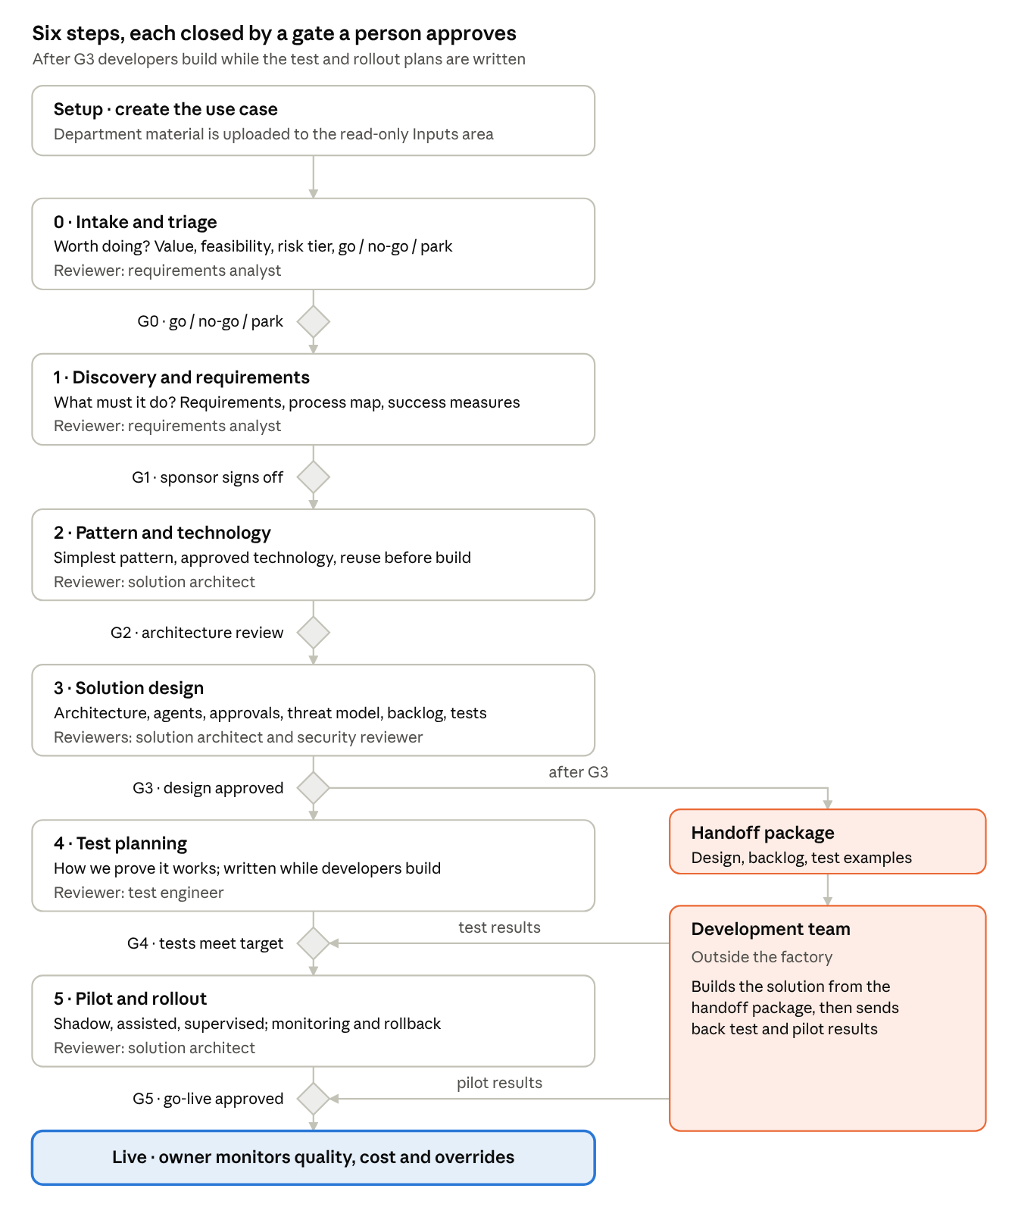
the factory journey · 6 steps, 6 gates
Steps 0 to 3 run in order with the department. After G3 the handoff lets developers start building while the test and rollout plans are written, and their results close G4 and G5.

Each step explained
Every step follows the same rhythm: Claude reads what is already there, asks only about gaps (at most five questions at a time), fills a standard document, has it reviewed by a specialist agent, fixes what the reviewer found, and records the outcome. Anything still unknown is logged as an open question with a named owner, never guessed.

Setup: start a use case
The product owner creates the use case with a name, department, sponsor and SMEs. The factory gives it an ID (for example UC-002) and a folder. The department's material goes into its Inputs area, which is read-only: Claude reads it but can never change it.

Step 0: Intake and triage
Question answered: is this worth doing, and how risky is it?
- Summarizes the request, the current pain in numbers, who is affected and the volume of work
- Scores value and feasibility from 1 to 5
- Sets the risk tier (low, medium or high) and the highest level of AI autonomy allowed
- Recommends go, no-go or park
Reviewed by: Requirements analyst. Gate G0: the product owner confirms the decision.

Step 1: Discovery and requirements
Question answered: what exactly must the solution do?
- Use case canvas: purpose, users, inputs, outputs and numbered business requirements
- Process map: today's steps and the future steps, showing for each one whether AI, a person or a system does it, and where a person must approve
- Quality needs: accuracy target, speed, availability, record keeping, privacy, languages, accessibility
- Success measures with today's baseline and the target, plus numbered acceptance criteria
If the material is too thin, Claude writes an interview guide for a session with the department instead.
Reviewed by: Requirements analyst. Gate G1: the sponsor signs off the requirements.

Step 2: Pattern and technology
Question answered: what kind of solution is it, and what do we build it with?
- Chooses the simplest solution pattern that works, such as an assistant, a document processor or an agent, and names the runner-up
- Walks through the 11 building blocks of an AI solution (user interface, AI model, data, integrations, approvals, safety filters, monitoring and so on), marking each as needed or not
- Picks technology only from the approved internal list and marks each component as reuse, extend or new
- Records the reasoning behind non-obvious choices
Reviewed by: Solution architect. Gate G2: architecture review.

Step 3: Solution design
Question answered: how will it work, and is it safe?
- Architecture: the parts, how data flows between them, and the systems it connects to
- Agent specifications: for each AI agent, its job, the tools it may use and the limits on what it may do alone
- Human approval design: where people approve, what they see on screen, and what happens if they reject or do not respond in time
- Threat model: security risks, including AI-specific ones such as hidden instructions in documents, and the controls against each
- Backlog: user stories, each linked back to the requirements it delivers
- Test examples: a set of realistic cases with the correct answers (25, 100 or 250 depending on the risk tier)
Reviewed by: Solution architect and Security reviewer. Gate G3: design and security risk assessment approved.

Handoff to developers
Right after G3, the factory assembles the handoff package: a README on what to build and where to start, all the design documents, and a briefing file so the developers' own AI assistant follows the same design, reuse rules and autonomy limits. The development team can start building immediately.

Step 4: Test planning
Question answered: how will we prove it works?
Runs in parallel with development. The test plan covers functional tests, AI quality checks against the test examples, attack tests based on the threat model, user acceptance tests with the department, and a performance and cost test at real volume.
Reviewed by: Test engineer. Gate G4: passed later, once the development team's results meet the accuracy target and the department has signed off acceptance testing.

Step 5: Pilot and rollout
Question answered: how do we go live safely?
- A staged rollout: shadow (AI runs silently alongside people), then assisted (AI suggests, people decide), then supervised (AI acts within limits)
- What to monitor (quality, how often people override the AI, cost, incidents) and the thresholds that trigger action
- A rollback plan, support model, owner after go-live and a re-review date
Reviewed by: Solution architect. Gate G5: go-live approval, based on pilot results.

Gate checks
A gate is passed only when two checks agree and a named person approves:
- Automatic check: confirms every required document and section exists, nothing is left empty, and every requirement is traced into the backlog and tests
- Gate reviewer: an independent AI reviewer judges quality against the governance criteria for that gate and risk tier
- Human approval: the required approvers are recorded by name and date
If a gate fails, the factory lists the gaps to fix and the check is run again.

Portfolio status
At any time, the status view shows every use case with its phase, risk tier, status, next gate and days in the current phase.

The five reviewer agents
Five specialist AI reviewers check the drafts, so no document is graded by the same assistant that wrote it. They can only read; they report issues, and the main assistant makes the fixes, which keeps a clear record of what was found and what changed.
Reviewer | Used in | What it checks, in plain terms
Requirements analyst | Steps 0 and 1 | The problem is real and measured; the risk tier is justified; every requirement can be tested; every future step has an owner (AI, person or system) and stays within the allowed autonomy; nothing was invented
Solution architect | Steps 2, 3 and 5 | The simplest workable pattern was chosen; every component serves a requirement; existing internal components are reused; the design hangs together and can be built; the rollout plan has clear stages, thresholds, rollback and an owner
Security reviewer | Step 3 and gate G3 | Data is protected at every hand-off; each AI agent has only the access it needs; AI-specific threats are covered (hidden instructions in documents, data leaks, an agent doing too much, runaway cost); human approvals cannot be bypassed; actions are logged
Test engineer | Step 4 | Every requirement and acceptance criterion has a test; the test examples are large and varied enough; attack tests match the threat model; acceptance and performance tests exist
Gate reviewer | Every gate | Judges whether the gate's criteria are met for this risk tier; any unresolved serious issue from earlier reviews fails the gate; lists the people who must approve
Every finding is rated the same way:
- Blocker: the gate cannot pass until it is fixed
- Major: must be fixed before handoff
- Minor: worth improving

Built-in safeguards
Risk tier sets the depth. Each use case is rated at intake on data sensitivity, decision impact, autonomy wanted and who is affected. The highest factor wins.
 | Tier 1 Low | Tier 2 Medium | Tier 3 High
Typical example | Internal summarizer, public data, AI only suggests | Staff workflow with sensitive data, AI drafts for approval | Affects the public or decisions about people, or AI acts on its own
Security review | Short checklist | Full threat model | Full risk assessment and formal security sign-off
Test examples needed | 25 | 100 | 250, including edge cases
Rollout stages | Assisted | Shadow, then assisted | Shadow, assisted, then supervised
Gate approvers | Product owner | Product owner and architecture | Product owner, architecture, security and sponsor
Autonomy is set per step, not per solution. One solution can mix levels, and no step may exceed the limit set at intake.
Level | AI does | People do
L0 Suggest | Recommends or drafts, takes no action | Decide and act
L1 Draft for approval | Prepares the action fully | Approve, edit or reject before it runs
L2 Act with review | Acts; the result can be reversed | Review samples and reverse errors
L3 Act and notify | Acts within limits and reports | Handle exceptions
Other protections
- Nothing is invented. Unknowns become open questions with an owner, and a gate cannot pass while an untracked question remains.
- Department material stays untouched. The Inputs area is read-only for the AI.
- Standards are protected. Templates and reference catalogs can only be changed when the product owner deliberately unlocks them.
- Full audit trail. Every decision is logged with date and person, and the log can only grow. Every review is kept.
- Approved technology only. Designs may use only technologies on the organization's approved list.

How to start a request
- Contact the product owner with a short description of the problem and a named sponsor.
- Gather the material below; notes, emails, documents and spreadsheet exports all work.
- The product owner creates the use case, uploads the material and runs intake.
- Expect a few rounds of questions; answering them quickly is the biggest factor in speed.
Make sure the required information listed near the top of this page is included.
Helpful to add
- Real past examples with the correct outcome; these become the test examples
- Rules, policies or standards the AI must follow
- Templates and good examples of the expected output
- Systems involved and who owns them
- Known risks and "must never happen" rules

FAQ
Does the factory build the AI solution? No. It produces the requirements, design and plans. The development team builds the solution from the handoff package.
Can the AI approve its own work? No. Specialist reviewers check every draft, and every gate needs a named person to approve.
What if we don't know an answer yet? It is recorded as an open question with an owner. Work continues, and the question must be resolved or accepted before the gate that needs it.
How long does it take? It depends mostly on how quickly questions are answered and approvals given. Low-risk use cases follow a lighter path with fewer required documents.
Can our department's documents be changed by the AI? No. Uploaded material is read-only.
What happens after go-live? The rollout plan names an owner, the measures to watch and a re-review date.

